Times Tables Support

At Priory School, we teach times tables explicitly using different strategies. See below for some ideas about how you could support your child at home.

Children start by seeing multiplication as repeated addition. You could make equal groups of items you find at home, such as dried pasta.

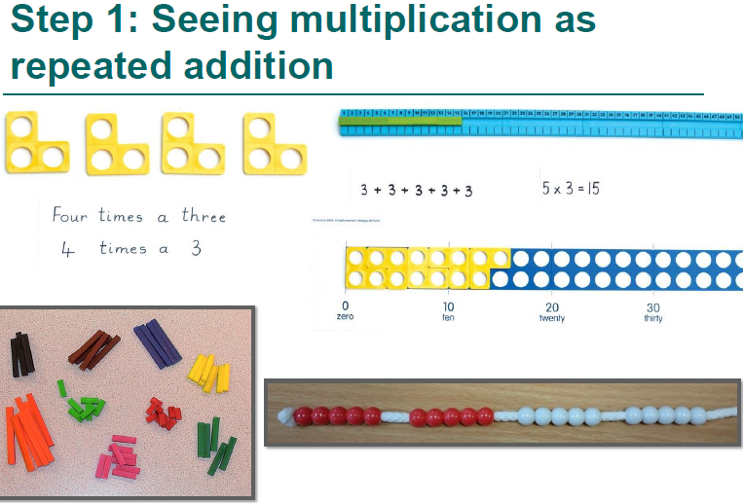

In KS1, children begin to use written methods for multiplication, including number lines and arrays. Children will step count using their fingers.

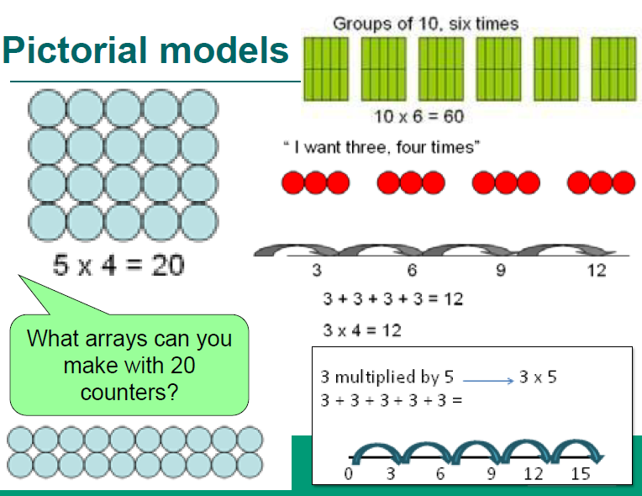

Language used in school for multiplication:

Children need to know that multiplication can be expressed in different ways.

For example:

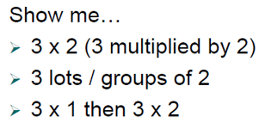

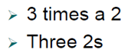

The ‘multiplicand’

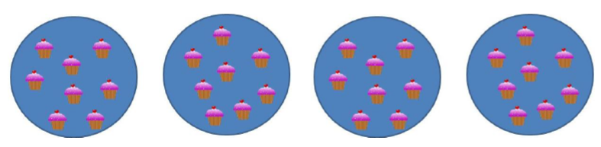

* Establish that ‘8’ is the number in the group and is the number to be multiplied. ‘8’ is the multiplicand. We are counting in 8s.
* Say, “8 is the multiplicand” to your child and get them to repeat the full sentence to help build confidence in using precise language.

The ‘multiplier’



* The multiplier is shown by the number of the number of repeated multiplicands.

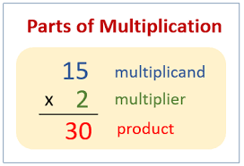 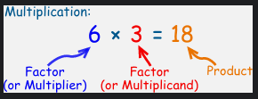

Useful websites:

[Times Tables Rock Stars (ttrockstars.com)](https://ttrockstars.com/)

[Times Tables Games (topmarks.co.uk)](https://www.topmarks.co.uk/maths-games/7-11-years/multiplication-and-division)

[MTC - Multiplication Tables Check - URBrainy.com](https://urbrainy.com/mtc)

Times Table songs:

[2 Times Table Song (Cover of Can’t Stop The Feeling! By Justin Timberlake) - YouTube](https://www.youtube.com/watch?v=9C4EN7mFHCk)

[4 Times Table Song (Cover of I’m Still Standing by Taron Egerton) - YouTube](https://www.youtube.com/watch?v=8QU_E0u-tP4&list=RD8QU_E0u-tP4&start_radio=1)

[6 Times Table Song (Cover of Shake It Off by Taylor Swift!) - YouTube](https://www.youtube.com/watch?v=e7rYbk9PNuM)

[8 Times Table Song (Cover of Rolling In The Deep by Adele) - YouTube](https://www.youtube.com/watch?v=z_BJjR9rdwA&list=RD8QU_E0u-tP4&index=2)

[Multiply by 9 | Learn Multiplication | Multiply By Music | Jack Hartmann - YouTube](https://www.youtube.com/watch?v=3p-ZIcTxtxw)

[KS1 Maths Collection - BBC Teach](https://www.bbc.co.uk/teach/supermovers/ks1-maths-collection/z6v4scw)